Shabbos Stories For
Parshas emor 5786
Volume 17, Issue 34 15 Iyar/May 2, 2026
Printed L’illuy nishmas Nechama bas R’ Noach, a”h
Two Inspiring Stories
The Right Person, in the Right Place
By Rabbi Moshe Hirschberg

A prominent askan from Brooklyn once shared with me a hair-raising story that vividly illustrates the remarkable workings of hashgachah pratis.
About thirty years ago, on an Erev Shabbos shortly before Purim, he received a frantic phone call from Manchester. On the other end of the line was his brother, speaking in a trembling voice. “Tatty had a stroke. You must come as soon as possible.”
Immediately, the askan began making preparations. His father-in-law arranged a passport for him, and Rabbi Hillel David gave him $800 toward the cost of the flight.
The plan was simple: As soon as Shabbos ended, he would rush to the airport and try to secure a standby ticket. (In those days, one could still purchase a ticket directly at the airport.)
He was hoping to board a 10:00 p.m. flight to Germany. But when he arrived at 9:50, he realized that he was just a few minutes too late. The gate had already been closed. Then he heard about an Air France flight to Paris that had originally been scheduled for 8:00 p.m., but had been delayed until midnight. Quickly, he purchased a standby ticket.
But there was a problem. The ticket cost him $680, leaving him with only $120. The connecting flight to Manchester would cost $180. He was now $60 short. As if that were not enough, he could not even call his family. This was long before the days of cellphones. The only way to make a call was with a calling card — and to buy one, you had to go to the post office, which was closed on Sundays.
Desperate, he began walking through the Paris airport, hoping perhaps to find a kind Yid who could help him.
Instead, he noticed an Arabic looking man staring intently at him. He tried to ignore the gaze and continued walking. But the man followed him, his eyes fixed on him the entire time.
After trailing him for several minutes, the stranger finally approached. “Are you married to Chumi Clurman*?” he asked.
The askan stared at him in astonishment. “Yes,” he replied.
“I was at your wedding,” the man said. “Your wife worked with me, and she invited me to the chasunah.” The askan suddenly realized that the man was a religious Jew.
“Is there anything I can do for you?” the man asked. The askan shared his predicament — his father’s illness, his desperate need to reach Manchester, and the fact that he lacked enough money for the connecting flight.
Without hesitation, the man pulled out the needed cash on the spot. But he didn’t stop there. He took him to the only kosher restaurant in the area, ensured that he had something to eat, and showed him where he could daven Minchah before boarding his flight.
Then the man explained something remarkable.
“I’ll tell you why I’m here,” he said. “I received a letter that my aunt was arriving today, so I came to the airport to pick her up. But when I arrived, I realized that I had come on the wrong day.”
He paused.
“I knew there must have been a reason Hashem brought me to the airport today. And now I understand why. When I saw you, everything fell into place.”

At the Right Time
By Rabbi Moshe Hirschberg

(Cont.) Fast Forward Several Years…
It was Rosh Hashanah night. The beis medrash of Torah Vodaath was filled with the special atmosphere of Yom Tov. People were dressed in their finest clothing, and the air was permeated with awe and holiness.
From the back of the beis medrash, the askan noticed an older Slonimer Chassid quietly entering. But something about him seemed different. His face reflected deep distress — something far heavier than the natural awe of Rosh Hashanah.
The man shared that his wife was critically ill, and her condition had suddenly deteriorated. He was unsure if she would survive the night. The askan tried to comfort him as best he could. But the next morning he heard the devastating news: she had not survived the night.

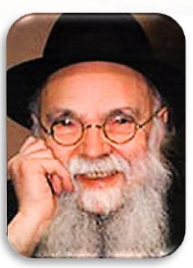
Rav Avraham Pam

The askan presented the complicated situation to the great rosh yeshivah, Rabbi Avraham Yaakov Pam, who ruled that the kevurah should take place only after Yom Tov. Because that year Yom Tov extended into three days, the burial would have to wait until after Shabbos. In the meantime, the matter was handed over to the chevra kadisha.
On Sunday morning, while attending the levayah, the askan was approached by Rabbi Pasternack, the officiating Rav. The Rav explained that the burial would take place in a distant beis hachaim. Because of his age, and since it was Tzom Gedalyah, he asked the askan to represent him at the burial.
“But I know nothing about officiating!” the askan protested.
“So, I’ll teach you,” the Rav replied. He carefully reviewed all the relevant halachos, explaining exactly what needed to be done so that the woman could receive a proper kevurah.
When they arrived at the cemetery, they discovered another problem: There were only nine men present. Finding a tenth person to complete the minyan seemed almost impossible. One of the relatives suggested waiting a few minutes, as a nephew was planning to come.
They waited. Several minutes passed. Suddenly, a car pulled into the cemetery. The door opened. And out stepped — the very same man who had helped the askan years earlier in the Paris airport. Once again, the right person had appeared in the right place at the right time.

The Story Continues…

Years later, that same man opened a business in Brooklyn. At one point, he was searching for an employee and contacted the askan. “Would your wife be interested in working for me?” he asked. The askan explained that she had indeed been looking for a job.
And so, decades after she had once worked with him and invited him to her chasunah, the circle closed. For the next several years, the askan’s family was supported by the income that job provided. Looking back, the askan marveled at the unfolding chain of events — a simple invitation to a chasunah, a chance meeting in an airport, a burial that needed a tenth man, and a job that later sustained a family.
Often, we see only isolated moments — confusing encounters that seem random or inconvenient. But Hashem is weaving a far bigger tapestry.
The person we meet today…
The kindness we extend…
The invitation we offer…
Years later, we may discover that it was all part of a perfectly orchestrated plan. Sometimes the right person appears at the right place at the right time. And only afterward do we appreciate that it was orchestrated by Hashem Who’s guiding every step along the way.

Reprinted from the Parshas Tzav 5786 email of Zichru Toras Moshe.

The Benefits of
Severe Humiliation

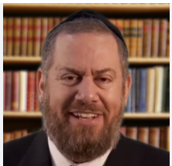
Rabbi Ephraim Eliyahu

A number of years ago, in the quiet hum of a kosher restaurant in Southern Florida, Rabbi Ephraim Eliyahu sat with his wife and daughter when the atmosphere of the dining room was suddenly shattered by a harsh commotion. Four young women, visitors from a foreign country, were relentlessly lambasting their waiter. They shouted over trivialities - the temperature of their drinks and the quality of the cheese. Their words were sharp, public, and demeaning, aimed at a young man in his early twenties who stood defenseless against the verbal onslaught.
The waiter, a man by the name of Shoam, stood paralyzed. He didn’t fight back; he didn’t offer a sharp retort. Instead, he absorbed the humiliation in silence. Rabbi Eliyahu watched the scene with a mix of indignation and hesitation. He felt he should intervene, perhaps even ask the women to leave the establishment for their reprehensible behavior, but he found himself frozen in place.
It was his wife who broke the spell. She reminded him of the words of Chazal that when a person is publicly shamed and chooses to suffer his humiliation in silence, they are granted a rare and potent spiritual power to bestow a beracha upon others.
“Call the waiter over,” she urged her husband. “Ask him for a beracha.” Reluctant but trusting, the Rabbi called Shoam to their table. He asked the young man his name and his age. Shoam, still reeling from the public lashing, looked at the Rabbi with confusion, wondering if this was just another part of the joke.
“I am a Rabbi in this community,” he said with absolute sincerity. “You were just humiliated, and you stayed silent. You have the power to give a blessing right now, and I want one for my family.”
Moved by this sudden pivot from cruelty to profound respect, Shoam mumbled a blessing of sorts, but as he walked away, the tears he had been holding back finally came crashing down.
Five minutes later, Shoam returned to the table, his face transformed. He asked to speak with the Rabbi and shared a story that had been buried for nearly two decades. Shoam had been raised religious (dati) in Israel, studying Mishnayos with his father. But the connection began to fray. By twelve, he had drifted away. By seventeen, he had left Israel for America, entirely disconnected from his heritage. He was living a completely secular life. He married a non-religious woman from Argentina and they were building a life in North Miami Beach, far removed from the world of the yeshivah.
“Rabbi,” Shoam said, his voice thick with emotion, “it has been sixteen years since I felt I had any relationship with my family or my faith. But if you could care about me - a total stranger, a mere waiter in a small food establishment - and if you believe that I have the power to give a blessing, then I am ready to come back into the fold. I am ready to be religious again.”
The rabbi and his family were shocked at first, and then delighted with his decision. The recognition of Shoam’s inherent kedusha even in his moment of lowest humiliation was the spark. Shoam began the journey of becoming a real baal teshuva. Rabbi Eliyahu helped him find a study partner to begin learning Torah again.
Over the next few years, the transformation was total. Shoam’s non-religious wife joined him on this path of return. They traveled to Israel to reaffirm their marriage in a religious ceremony. A year later, Shoam called Rabbi Eliyahu to invite him to the bris of his newborn son. Today, Shoam and his wife are among the most dedicated members of their community in North Miami Beach. They are true pillars of faith, all because a stranger chose to see the power of his soul instead of the stains on his apron.

Reprinted from the Parshas Tzav 5786 email of Rabbi Dovid Hoffman’s Torah Tavlin.

The Pessimistic Jewish Bookstore Owner
By Rabbi David Sutton

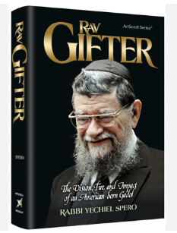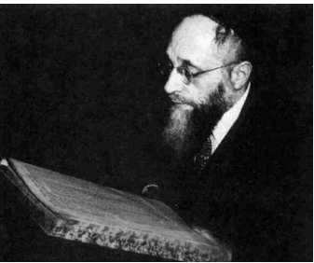
Rav Mordechai Gifter and Rav Eliyahu Meir Bloch

Soon after World War II, R’ Mordechai Gifter—later rosh yeshivah of Yeshivas Telshe in Cleveland—accompanied R’ Eliyahu (Elya) Meir Bloch, then rosh yeshivah of Yeshivas Telshe, on a fundraising trip to New York. While there, they stopped at a Jewish bookstore. R’ Elya Meir wished to purchase a volume of Ketzos HaChoshen. They introduced themselves to the elderly storeowner and requested the sefer.
As he searched, they glanced around the store. It was a place for Jewish items—candlesticks and siddurim—but not necessarily sefarim. Finally, the old man climbed a ladder and retrieved a copy that had clearly been sitting there for quite some time. Just as he was about to hand it over, he pulled it back and looked intently at R’ Elya Meir. “I will sell you this sefer on two conditions,” he said. “First, I understand you lost your entire family in the war and intend to rebuild what was lost in Europe. Please—don’t try it! You’re committing emotional suicide. There is only so much heartache one man can take. There is no place for a yeshivah here in America. You’ll never succeed.” “Second,” the man continued, “America is not a country where Torah will flourish. What we had in Europe is gone; what Hitler destroyed cannot be rebuilt. Treat this as a relic, because this may be the last Ketzos ever sold in America.” R’ Elya Meir said nothing. He purchased the sefer and left. After a few moments, he turned to R’ Gifter and said quietly, “He’s right. Al pi seichel, there is no chance for Torah to survive here.”

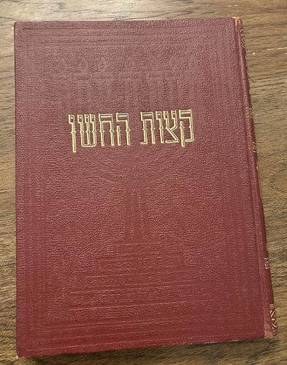

“But Torah does not work with logic! The power of Torah is beyond all logic. Torah can cause a yeshivah to blossom and Ketzos to be learned. More copies of the Ketzos HaChoshen will be printed and bought in America than ever before in history. And you will see, Telshe will be rebuilt here in America!” History proved R’ Elya Meir right. More copies of Ketzos HaChoshen have been produced and purchased in America than ever before. Additionally, Telshe, and many, many other yeshivos, were rebuilt in America as well.

Reprinted from the Parshas Vayikra 5786 edition of At the ArtScroll Shabbos Table. Excerpted from the new ArtScroll book – “The Bitachon Haggadah” by Rabbi David Sutton.
You Are Worth It!
By Rabbi Yoel Gold

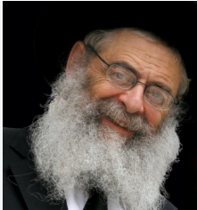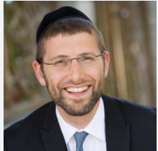
Rabbi Dovid Trenk (left) and RabbiYoel Gold

It was the final week of high school. I was preparing to graduate from Adelphia Yeshiva, filled with anticipation for the next chapter of my life. My plan was clear: I would be continuing the following year in Passaic, New Jersey.
Then, one day, my rebbe, Rabbi Dovid Trenk zt”l, walked into the Beis Medrash, sat down beside me, and said quietly, “Yoeli, I want you to stay next year in Adelphia to help build the Beis Medrash.”
My heart sank.
At that time, the Beis Medrash was just beginning. There were only three students. If I stayed, I would be the fourth. It was not yet a fully developed makom Torah, and I had already set my sights elsewhere. I responded honestly. “Rebbe, I’m planning to go to Passaic. I don’t think I can stay.” But it is not easy to say no to a rebbe like Rabbi Trenk. I asked for time to think it over.
The next day, he returned and said simply, “Yoeli, get into the car.” “Where are we going?” I asked. “I’ll tell you on the way.”
We drove down Route 9 and onto the Staten Island Expressway. Then he turned to me and said, “I’m taking you to a din Torah. We’re going to ask Rav Shmuel Berenbaum what you should do.” A short while later, we arrived. Rav Shmuel welcomed us in, and we sat down together. Rabbi Trenk began to speak, and then, unexpectedly, he broke down in tears.
“Rebbe,” he said, “Yoeli has spent four years in Adelphia. I want him to stay another year to help build the Beis Medrash. Please tell him to stay.”
Shmuel then turned to me, took my hand, and gently asked, “Nu, what do you say?” With a trembling voice, I answered, “Rosh Yeshiva, I am deeply grateful—to my rebbe, to the yeshiva—but I feel it is time for me to move on. I believe I will grow more in Passaic.” He looked at me and said simply, “If you will learn better there, then go.”
I turned to Rabbi Trenk. There was a faint smile on his face.
We got back into the car and drove home in silence.
The following year, I went to Passaic. And from time to time, Rabbi Trenk would come visit. He would walk straight into the Beis Medrash, come over to my seat, lift me up in a warm embrace, and say, “Yoeli, I am so proud of you.”
Twenty years later, I received the call. The rebbetzin informed me that Rebbe had passed away. I flew from Los Angeles to Lakewood, and throughout the flight, I replayed memories—moments, conversations, experiences—that had shaped my life.
And then I remembered that episode.
I felt a deep sense of guilt. After the shivah, I called the rebbetzin and said, “Do you remember what happened? I feel like I owe Rebbe an apology.”
She began to laugh gently. “Yoeli,” she said, “you do not owe my husband an apology. He knew it was time for you to go. He understood that. But he wanted you to know how much he wanted you to stay. How much he valued you.”
Then she said something I will never forget.
“He wanted you to carry that with you into life. So that when you face challenges, when things become difficult—as they do for everyone—you will remember that you are worth fighting for.”
In that moment, everything became clear. Like a light turning on, I realized that throughout the years, whenever I struggled, I kept pushing forward. I kept fighting. Because somewhere deep within me, my rebbe had planted that truth: you are worth fighting for.
And that is a message not just for me, but for every person. Your ruchniyus is worth fighting for. Your struggles do not define you, and your setbacks do not disqualify you. No matter how many times a person falls—once, a hundred times, a thousand times—it does not matter. Get back up and continue fighting.
Because you are worth fighting for.

Reprinted from the Parashat Vayikra 5786 email of the TorahAnyTime Newsletter. Compiled and edited by Elan Perchik.

Tears for Eternity
By Rabbi Yehuda Zev Klein

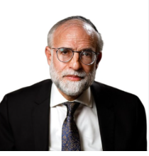
Rabbi Yehuda Zev Klein

My son-in-law, R’ Shloime Grossnass, once shared with me a remarkable story passed down through his family.
In the 1920s, his great-great-grandparents were forced to relocate from Poland to Germany. One Friday evening, their teenage son was walking home when he suddenly heard the sound of crying—deep, heartfelt sobbing—coming from a nearby house. Drawn by the intensity of the moment, he approached the window.
Inside, a woman had just lit her Shabbos candles.
With tears streaming down her face, she poured out her heart in tefillah: “V’zakeini le’gadel banim u’bnei banim…her children should grow to be wise, G-d-fearing, devoted to Torah and good deeds.” Her words were not routine. They were alive, filled with longing, with a mother’s deepest yearning.
The boy stood there, transfixed. He had never heard such sincerity, such depth, such pleading before. In that moment, something shifted within him. A decision crystallized. “I want to become the kind of talmid chacham she is davening for. I want to live with that yiras Shamayim.”
The next day, he told his parents that he wanted to travel to Radin to learn in the yeshiva. They agreed, and he began preparing. The journey was long and difficult, but he arrived determined and hopeful. He was tested.
And then he was told: “We’re sorry. You’re not yet on the level required to keep up with the yeshiva.” He was crushed. All the effort, all the preparation, all the anticipation collapsed in an instant. He left the building, sat down on a bench, and broke into tears.
At that moment, Rabbi Naftali Troup passed by and noticed him. “What happened?” he asked gently. “Why are you so distressed?” The boy explained everything—his journey, his aspiration, his rejection. “Where are you from?” the Rav asked. “Germany.” “Aren’t there yeshivos in Germany?”
“Yes,” the boy replied. “But there, they learn during the day. Here, they learn day and night—Shabbos and Motzei Shabbos, Yom Tov and after Yom Tov. Here, Torah is everything. That is what I want.” When Rabbi Naftali Troup heard those words, he paused. And then said, “If that is what you desire, come. You are accepted.”
From that point on, the young man flourished. He grew into one of the most outstanding students in the yeshiva, and later continued his learning in Baranovich under Rabbi Baruch Ber Leibowittz zt”l. He became one of his closest and most distinguished students. In time, he married, and eventually became a leading Rav, known as Rabbi Aryeh Leib Grossnass, the Av Beis Din of London.
But the story does not begin there.
It begins with a woman. A mother standing alone, on a quiet Friday evening, lighting candles and crying.
Imagine, after one hundred and twenty years, when she ascends to Shamayim. She is shown generations of talmidei chachamim, generations of yirei Shamayim, entire worlds of Torah that emerged from that single moment of tefillah.
“Look,” they will tell her. “See what your tears created. See what your yearning built.” The greatness of Torah does not begin in the Beis Medrash. It begins in the heart of a mother.
It is the Jewish women—their tefillos, their sacrifices, their quiet devotion—who plant the seeds of eternity. They infuse their children with emunah, with values, with a love for Torah that shapes not only a life, but generations.
And sometimes, one tear, just one, can change the destiny of the world.
Forever.

Reprinted from the Parashat Vayikra 5786 email of the TorahAnyTime Newsletter. Compiled and edited by Elan Perchik.
Long Term Memory
By Rabbi Paysach J. Krohn
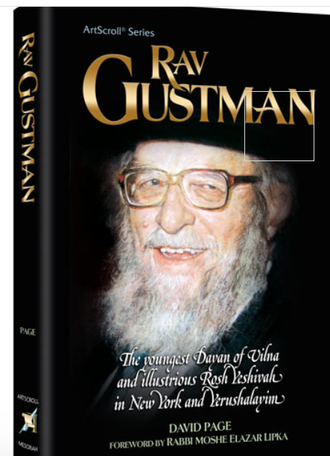

When Rabbi Yisroel Zev Velvel Gustman (1908-1991), Rosh Yeshivah of Yeshivah Netzach Yisrael (located first in Brooklyn and eventually in Jerusalem), was nine years old, he was already known as an exceptional matmid (one who is extremely diligent in his studies). His father R’ Avraham Zvi, who owned a forest and dealt in lumber, knew the entire Talmud and often traveled to consult with the Hafess Hayim. Often, he would ask little Yisroel Velvel to accompany him to visit the great saddik, but each time the boy would say
that he didn’t have time, for he was busy learning with his study partner.
Just before his father was about to depart for one of those visits, Yisroel Velvel and his partner were in the midst of learning Bet Kor, the seventh chapter of Baba Batra, which contains lengthy, mathematically intricate comments by the Rashbam. The Rashbam’s calculations seemed confusing to the two boys, and the basic meaning eluded them. The boys were convinced that even if they understood what the Rashbam meant, they would surely forget it soon afterwards, so they wondered whether it might not be advisable to skip these comments and go on to other segments of the masechet which they could more readily understand and retain. Yisroel Velvel decided to accompany his father and ask the Hafess Hayim what to do about his predicament.
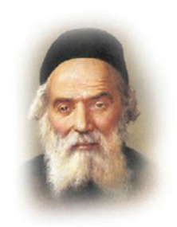
The Hafess Hayim

The youngster had the opportunity to ask the Hafess Hayim his question about learning those Rashbams, and the reply stayed with him for the rest of his life.
“Forgetting is like a cataract on the eye,” said the great Sage. “It hinders sight only until it is removed. While we are in this world we forget things, but that is merely temporary. Once the soul is in the Next World, there will be no such thing as forgetfulness; we will remember everything we ever learned. Thus, everyone must learn everything in Torah at least once [and understand it], so that it will stay with him for eternity in the Next World. If a person does not learn a segment of Torah in this world, however, it will be lost to him forever. Even in the Next World he will not be able to attain it.”
Unquestionably, one should strive to remember all that he learns. The Sages sharply condemn those who forget their learning due to negligence, laziness or indifference. The Keli Yakar presents an interesting gematria (numerical allusion) on the significance of hazarah, review.
Citing the Talmudic teaching that extols reviewing things 101 times (Hagigah 9b), Keli Yakar notes that the difference between the numerical value of jfa (forget), 328, and rfz (remember), 227, is 101. He explains that it is natural to forget, and it is only through constant review that one can retain his learning. Thus, each time one reviews what he has learned, he is diluting the forces of forgetfulness, and after he has studied it 101 times, it becomes firmly entrenched in his memory. (Along the Maggid’s Journey)

Reprinted from the Parashat Tsav 5786 email of Rabbi David Bibi’s Shabbat Shalom from Cyberspace.

